Linux Advanced
- Process monitoring and kill the port
- Service management - Install, Start and Stop the service (ssh)
- Create remote access (ssh) to a New user
- Create & Execute basic script
- Automat using script for creating 10 files

Commands Screenshots :-
- Process monitoring and kill the port

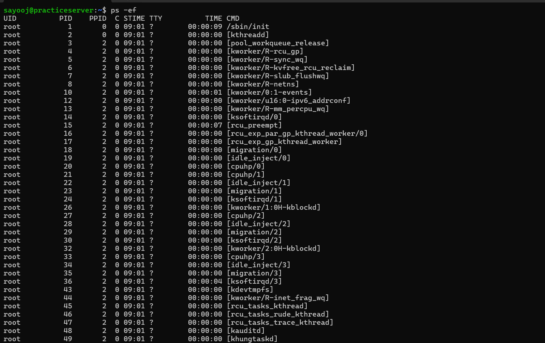
This screenshot demonstrates the use of the ps -ef command to display all active processes running on the Linux system. The output includes details such as the user (UID), Process ID (PID), Parent Process ID (PPID), CPU usage time, terminal (TTY), and the command associated with each process. It provides a complete view of system and kernel processes, which is useful for process monitoring and troubleshooting.
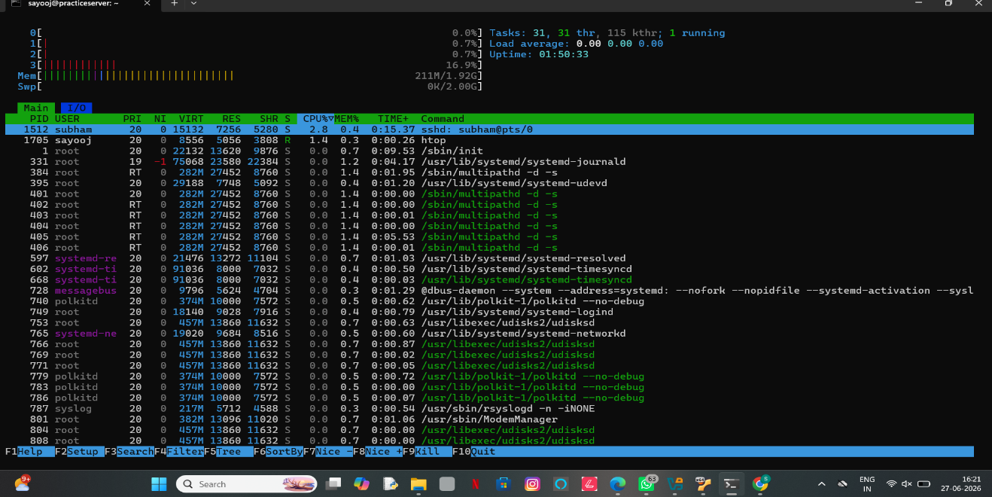
This screenshot shows the htop utility, an interactive process monitoring tool used to observe real-time system performance. It displays CPU and memory utilization, swap usage, system uptime, load average, and currently running processes. The interface allows users to monitor resource consumption, identify high CPU or memory usage, and manage processes efficiently.

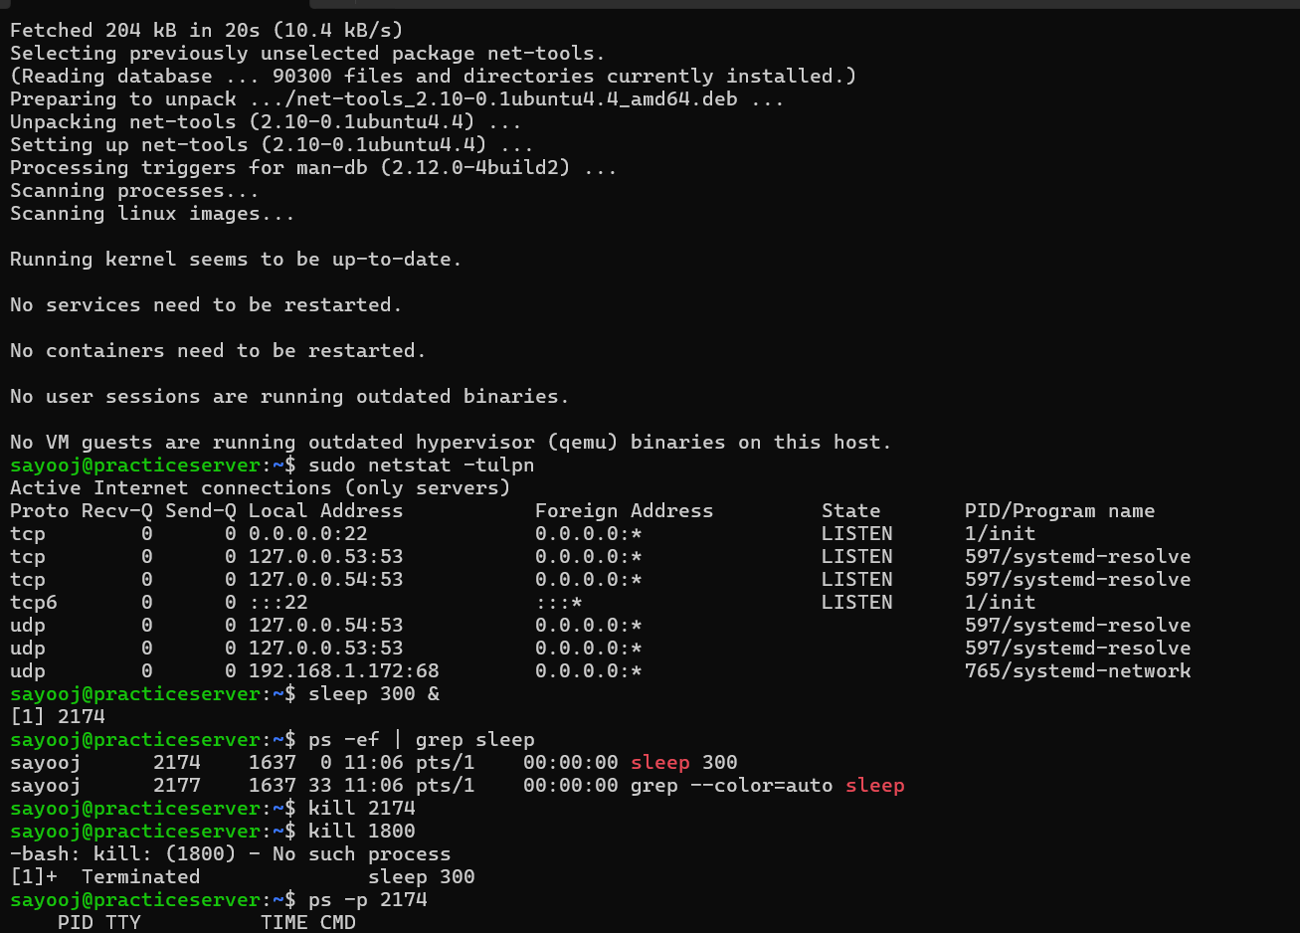
This screenshot demonstrates network and process management in Linux. The netstat -tulpn command is used to display active network connections, listening ports, associated protocols, and the processes using them. A background process is then created using sleep 300 &, verified with ps -ef | grep sleep, terminated using the kill command, and confirmed as terminated with ps -p <PID>. This demonstrates how to monitor network services and manage running processes from the command line.

- Service management - Install, Start and Stop the service (ssh)
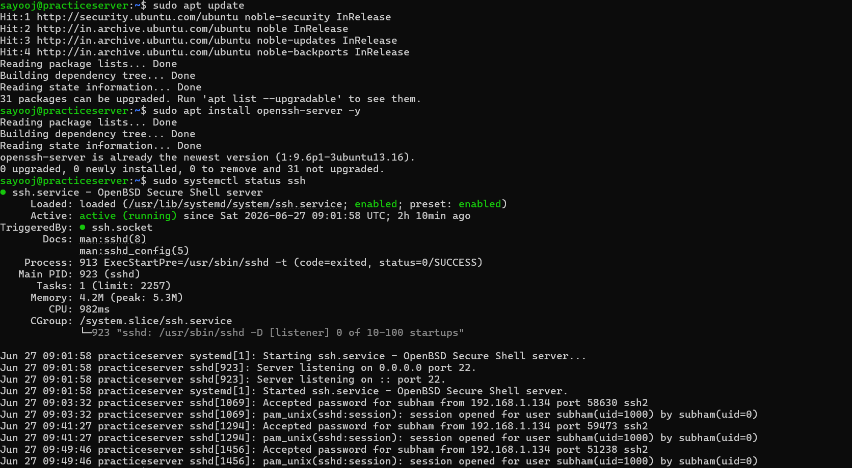
This screenshot demonstrates the installation and verification of the OpenSSH Server on an Ubuntu Linux system. The apt update command refreshes the package repository, followed by apt install openssh-server -y, which confirms that the OpenSSH server is already installed and up to date. The systemctl status ssh command is then used to verify that the SSH service is enabled and actively running. The service logs also show successful startup, listening on port 22, and successful remote SSH login sessions, confirming that the SSH server is functioning correctly and accepting client connections.

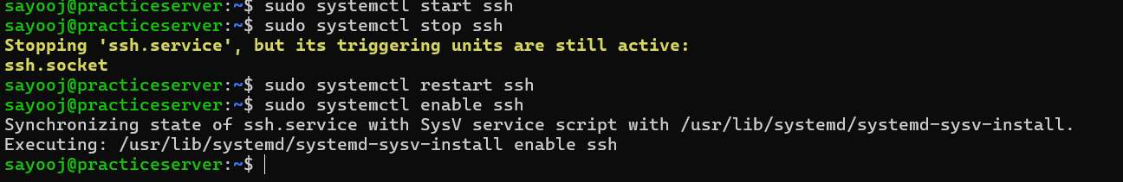
This screenshot demonstrates the management of the SSH service using the systemctl command. The SSH service is started, stopped, restarted, and enabled to start automatically during system boot. When the service is stopped, the system indicates that the ssh.socket trigger remains active, allowing SSH to be activated on demand. Finally, the systemctl enable ssh command configures the SSH service to launch automatically at system startup, ensuring continuous remote access availability.
- Create remote access (ssh) to a New user
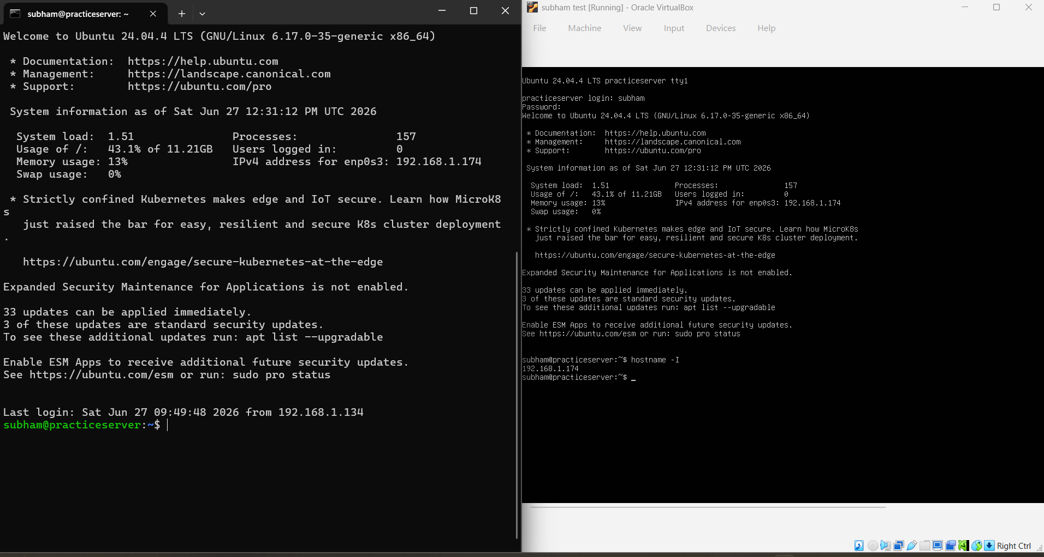
- Create & Execute basic script

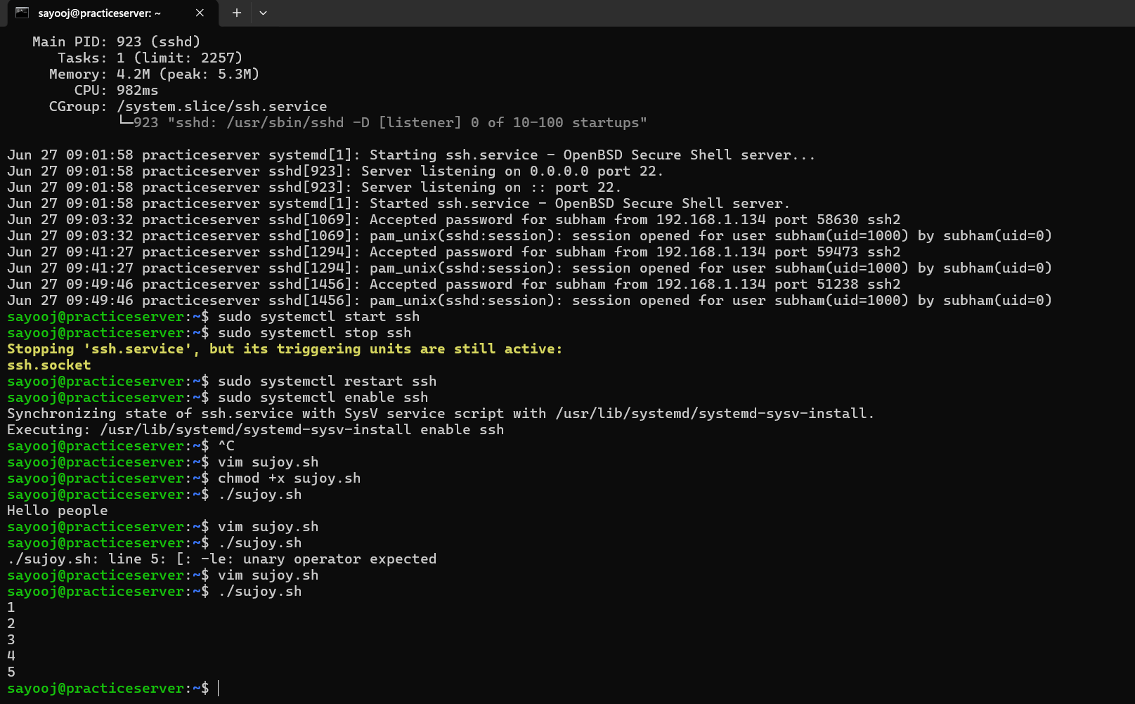
This screenshot demonstrates the creation, execution, and debugging of a Bash shell script in Linux. The script (sujoy.sh) is created and made executable using the chmod +x command. During the first execution, the script displays a "unary operator expected" error due to inconsistent variable naming (count vs. COUNT) in the loop condition. After correcting the variable name, the script executes successfully and prints the numbers 1 to 5, confirming that the while loop and variable increment logic are functioning correctly. This illustrates the importance of consistent variable naming in Bash, as variable names are case-sensitive.
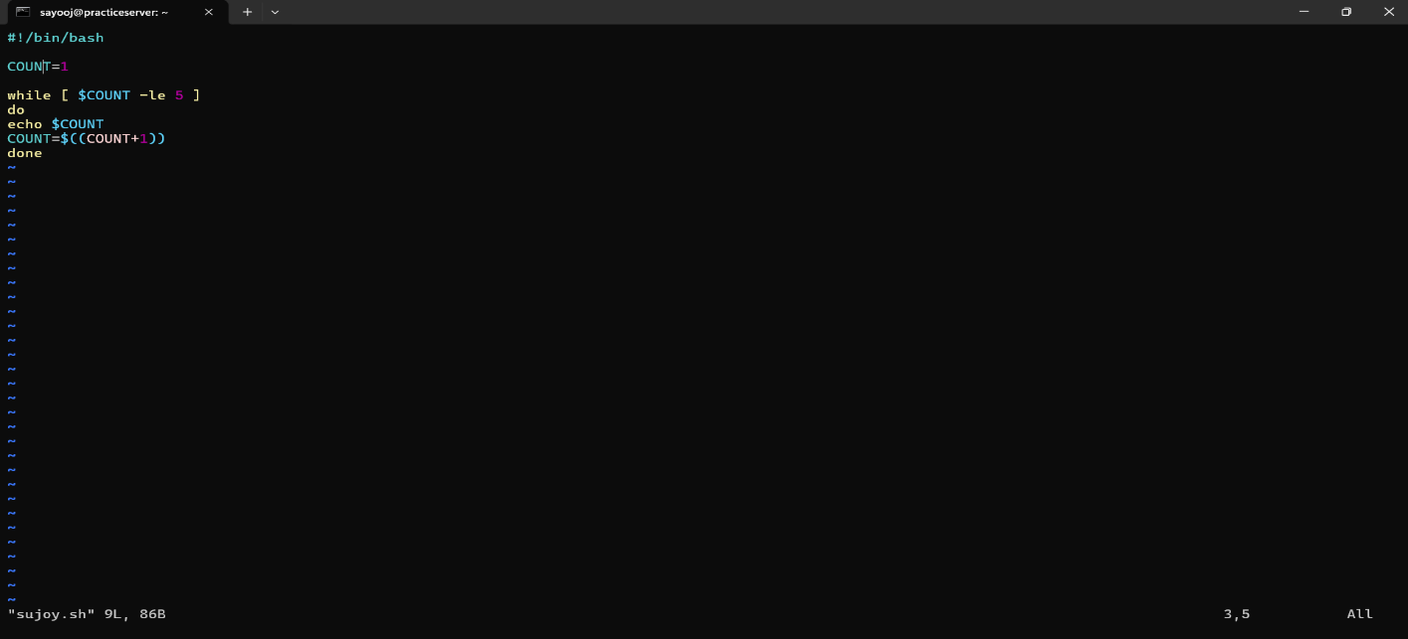
So this is the place where we write our logic for implementation.
So I have used a logic that is :-

#!/bin/bash
COUNT=1
while [ $COUNT -le 5 ]
do
echo $COUNT
COUNT=$((COUNT + 1))
done
Output :- It is the the first Screen Short.
- Automat using script for creating 10 files
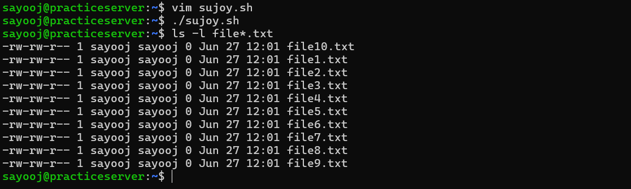

Implementation and Verification Steps :
- Script Editing: Opened and edited the script file using vim sujoy.sh.
- Execution: Ran the script via ./sujoy.sh to trigger the automated file creation loop.
- Validation: Executed ls -l file*.txt to print the directory contents (seen in Screenshot 2026-06-27 173409.png). The output validates that all 10 files were successfully generated simultaneously.
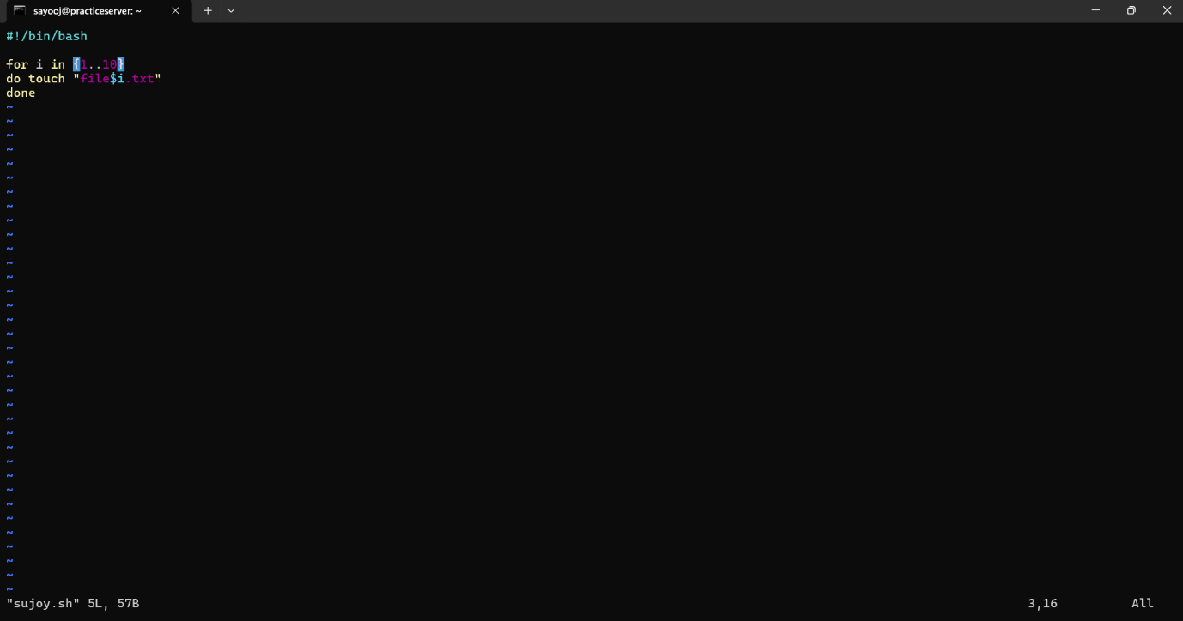
This is the logic that create the 10 text files automatically.
#!/bin/bash
# Loop from 1 to 10
for i in {1..10}
do
touch "file$i.txt"
done

